DBSE&DBD
Roll No: 2520030220
Name: G.ROHITH
Query-1:
Query-2:
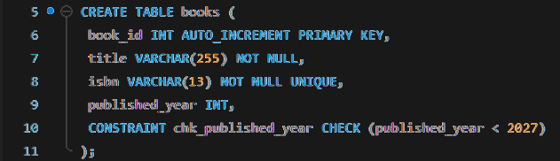
Query-3:
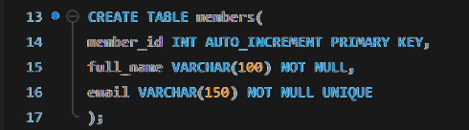
Query-4:
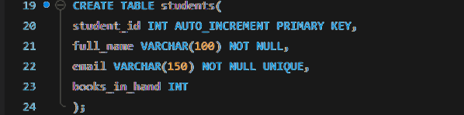
Query-5:
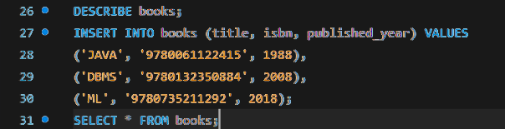
Books2:

Query-6:
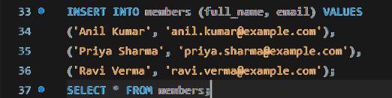
Members3:

Query-7:
